**A**

**Project Report**

**On**

**"Supply Cabinet"**

**Prepared by**

Chintan G Vekariya

**Under the guidance of**

Rima Patel and Priyal Vaghela

Assistant Professor

A Report Submitted to

Charotar University of Science and Technology

for Partial Fulfillment of the Requirements for the

3rd Semester Software Group Project-I (CE244)

**Submitted at**



**CSE**

**DEPSTAR**

**At: Changa, Dist: Anand – 388421**

**November 2020**



**CERTIFICATE**

This is to certify that the report entitled “**Supply Cabinet**” is a bonafied work carried out by **Mr. Chintan G Vekariya (19DCS156)** under the guidance and supervision of **Assistant Prof. Priyal Vaghela and Assistant Prof. Rima Patel** for the subject CE244 **Software Group Project-I** (CE/CSE/IT) of 3rd Semester of Bachelor of Technology in **DEPSTAR** at Faculty of Technology & Engineering – CHARUSAT, Gujarat. To the best of my knowledge and belief, this work embodies the work of candidate himself, has duly been completed, and fulfills the requirement of the ordinance relating to the B.Tech. Degree of the University and is up to the standard in respect of content, presentation and language for being referred to the examiner.

|  |  |
| --- | --- |
| Priyal Vaghela  Assistant Professor  Department of Computer Science & Engineering  DEPSTAR, Changa, Gujarat. |  |
| Rima Patel  Assistant Professor  Department of Computer Science & Engineering  DEPSTAR, Changa, Gujarat.  Dr. Amit Ganatra  Principal, DEPSTAR  Dean, FTE  CHARUSAT, Changa, Gujarat. | |

**Devang Patel Institute of Advance Technology And Research At: Changa, Ta. Petlad, Dist. Anand, PIN: 388 421. Gujarat**

**DECLARATION BY THE CANDIDATES**

I hereby declare that the project report entitled “**Supply Cabinet App**” submitted by me to Devang Patel Institute of Advance Technology and Reasearch, Changa in partial fulfilment of the requirement for the award of the degree of **B.Tech** in Computer Science and Engineering, from Devang Patel Department of Computer Science and Engineering, DEPSTAR/FTE, is a record of bonafide CE244 Software Group Project - 1 carried out by me under the guidance of **Assistant** **Prof. Rima Patel and Assistant Prof. Priyal Vaghela**. I further declare that the work carried out and documented in this project report has not been submitted anywhere else either in part or in full and it is the original work, for the award of any other degree or diploma in this institute or any other institute or university.

Chintan Vekariya (19DCS156)

Prof. Rima Patel

Assistant Professor cum Research Fellow

Department of Computer Science and Engineering

Devang Patel Institute of Advance Technology and Research

CHARUSAT, Changa.

Prof. Priyal Vaghela

Assistant Professor cum Research Fellow

Department of Computer Science & Engineering

Devang Patel Institute of Advance Technology and Research

CHARUSAT, Changa.

**ABSTRACT**

In today’s scenario, **Android Application development** is the process by which applications are created for devices running the Android operating system. Some programming languages and tools allow cross-platform app support (i.e. for both Android and IOS). The official Android app distribution mechanism to end users is Google Play. This is the immersing technology where people likes about it. As we know, it’s the generation of the Computers and Mobiles and in today’s world no one can live or do work without it. So, this is the necessary condition to have mobiles or PCs for their use. So, this will be the future of the computer field and people likes this android development. So, based on Android Development technology, our group has made up the app named “**Supply Cabinet**” which includes the management of the stocks of the company, management of the purchases and sales of the company and also takes care about the profits and loss of the company. We will purpose this app on Android platform through any Virtual Android Device. In this project, Android SDK manager is included which gives us the packages for our app. Any company can get this app and have the full experience of their management of the stocks as well as the profits – loss of their company.

**ACKNOWLEDGEMENT**

Me, the developer of this app “Supply Cabinet”, with immense pleasure and commitment would like to present the project assignment. The development of this project have given us wide opportunity to think, implement and interact with various aspects of management skills as well as the new emerging technologies.

Every work that one completes successfully stands on the constant encouragement, good will and support of the people around. I hereby avail this opportunity to express my gratitude to number of people who extended their valuable time, full support and cooperation in developing the project.

I express deep sense of gratitude towards our project guides Prof. Rima Patel and Prof. Priyal Vaghela for the support during the whole session of study and development. It is because of them, that we were dedicated to do hard work and adopting some new technologies.

I would also like to thank our mentor Ms. Ruchi Tank for his guidelines throughout the development phase of the game. She helped us, whenever we got stuck in the Android Develoment Concepts.

They altogether provided me favourable environment, and without them it would not have been possible to achieve the goal.

Thanks,

Chintan Vekariya

**TABLE OF CONTENTS**

ABSTRACT 4

ACKNOWLEDGEMENT 5

TABLE OF CONTENTS 6

List of tables ................................................................................................. x

**Chapter 1 Introduction..................................................................................... 8**

1.1 Project Overview ....................................................................................................8

1.2 Objective ................................................................................................................9

1.3 Scope......................................................................................................................10

1.4 Tools and Technologies.........................................................................................10

**Chapter 2 Project Management.................................................................... 11**

2.1 Project Planning ...................................................................................................11

2.1.1 Project Approach and Development...............................................................11

2.1.2 Project Justification .......................................................................................12

2.2 Project Motivation ................................................................................................13

**Chapter 3 System Requirements.................................................................. 14**

3.1 User Characteristics .............................................................................................14

3.2 Hardware and Software requirements...................................................................14

3.2.1 Hardware Specifications.................................................................................14

3.2.2 Software Specifications..................................................................................14

1. Visual Studio Code ........................................................................................14

2. Android Studio ...............................................................................................15

3. Android SDK Platform ..................................................................................15

4. Flutter Framework .......................................................................................16

5. SQFLite Packages .......................................................................................16

**Chapter 4 System Analysis........................................................................... 17**

4.1 System Working and Flowchart of Project........................................................17

**Chapter 5 Implementation and Testing...................................................... 23**

5.1 Implementation of Project ............................................................................... 23

5.2 Testing of Project .............................................................................................31

**Chapter 6 Future Performance Enhancement........................................... 33**

6.1 Predictions of App in Future.............................................................................33

**Chapter 7 Conclusion................................................................................... 34**

7.1 Self - Analysis ..................................................................................................34

7.2 Problems and their Solutions ...........................................................................34

7.3 Summary ..........................................................................................................34

**CHAPTER 1: INTRODUCTION**

**1.1 PROJECT OVERVIEW**

Android Application is the most immersing and developing feature in the whole world. As far as entertainment apps, these also provides to manage the work of the people as well as company. Android Application also provides the netbanking as well as shopping from any part of the world. There are all sorts of new possibilities as well. So, with this we think to develop an app for the efficiency of company taking care of the stocks and to manage as well deal with it. Stock Management is the function of understanding the stock mix of a company and different demands on that stock. The demands are influenced by both external and internal factors and are balanced by the creation of purchase orders requests to keep supplies at a reasonable or prescribed level. Stock management operates by monitoring both chief purposes of a warehouse. It includes like moving of things. Artificial materials are decremented and finished products are incremented.

* Supply Cabinet System is the most crucial and important app for the storing and updating the stocks for the whole app. This app heavily depends on the developing content of the person. We have developed this app using the Flutter Framework and Android Studio for the emulator to get the output of our app. The app starts with splash screen in which the logo of our app is shown and then get navigate to the home screen. When the home page get loaded, different widgets are there which will take then to the next screen.
* The home page of our app contains a side menu from which we can navigate to the help page as well as to the contact page. We also provide the logout button in the side menu through which they can logout their account and can login through different account .In the home page only, we have the bar at the end of the app in which we have home icon as well as the profile icon through which they can know about their profile details.
* This app can also do the analysis by sorting of the products that is in the trends among people. Also, this app focuses on the management as well as analysing the stock that is available in the company’s warehouse.
* This app is built to think of the company in the different way and explore that these things can also be done digitally in this era. Mostly, this app is for the company who want to manage the large contents of their products as well as time of the people and company too.

**1.2 OJECTIVE**

The main goal of this inventory management system is to keep the stock in such a way that it is neither overstock nor understock. To ensure a continuous supply of materials and stock so that production should not suffer at the time of customers demand. To avoid both overstocking and under-stocking of inventory in the company. The most integral part of the inventory management system is to evaluate your business on a regular basis to ensure your path towards success track. An inventory management system helps you to track and control the company’s supply so that you can optimize your inventory and manage them without spending extra time and money.

On this project, we mainly focuses on the inventory management of the company’s products. This app will work easily instead of the people who regularly needs to check the stocks for the company. By this app, work will become easy and efficiency will be better too. So, this app can be the game changing apps for the big business companies who want to do according to our app.

**1.3 SCOPE**

* The scope of an inventory system can cover many needs, including valuing the inventory, measuring the change in inventory and planning for future inventory levels. The value of the inventory at the end of each period provides a basis for financial reporting on the balance sheet. Measuring the change in inventory allows the company to determine the cost of inventory sold during the period. This allows the company to plan for future inventory needs.
* This inventory needed to decide the location, layout and types of storehouse. It facilitates the movement of materials and thus minimise the storage and handling cost of stores. The proper organisation structure of the system should be done effectively. The time that lapses between the raising of an indent by the stores and the receipt of materials by them. Lead time is of fundamental importance in determining inventory levels. Thus, we have to manage the time as well.
* As this is the generic app, these can be used by a wide variety of Retailers as well as Wholesalers in the market. By this, process of manually maintaining the records related to subject of maintaining the stack and cash flows.

**1.4 TOOLS AND TECHNOLOGY USED**

* Visual Studio Code
* Android Studio for Android devices (Pixel 3 XL, Pixel 3, Google Chrome using web script, etc.)
* Flutter Framework for app designing
* SQFLite for database of the app
* Adobe Photoshop (CS 6 or newer)
* Dart Language

**CHAPTER 2: PROJECT MANAGEMENT**

**2.1 PROJECT PLANNING**

**2.1.1 PROJECT APPROACH AND DEVELOPMENT**

Firstly, we think of to take the approach using the combination of Python with the Flutter Framework. But as we refer to some projects as well as some articles, we get to know about the Dart language more. So, we studied if this is possible with the Dart language. After that, the main fault was about the database to link with the frontend part of the framework. But as we know, Flutter is developed by Google and is the latest framework by providing platforms to the database as well as frontend part like creating and designing of the app. So, we thought to take the Flutter framework with the database and thus this happens.

Now, we face the problem from where to start? So, we thought that let’s take some references from the Google as well from our professors where they guide us well. We approach our project as one of the person from the group will take the responsibility of creating and designing part of the app. He will look after all the problems that will appear during the project. While other person of the group will do the database creating and connecting the database to our app. The most difficult part of the app is connecting the frontend part of flutter app with the backend part.

* For the frontend part of the app, we used the Flutter framework which includes the widgets through which app can be developed. Flutter widgets are built using a modern framework that takes inspiration from [React](https://reactjs.org/). The central idea is that you build your UI out of widgets. Widgets describe what their view should look like given their current configuration and state. When a widget’s state changes, the widget rebuilds its description, which the framework diffs against the previous description in order to determine the minimal changes needed in the underlying render tree to transition from one state to the next. Flutter comes with a suite of powerful basic widgets, of which the following are commonly used like Row() , Column() , Container() , Text() , etc.
* Now for the backend part of our app, we used the Flutter SQFLite package for using the query for creating and updating the database. A query is a question or inquiry about a set of data. We use Structured Query Language (SQL) to retrieve meaningful and relevant information from databases. When building a structure, we pull data from tables and fields. The fields are columns in the database table, while the actual data makes up the rows. Here, we need to run mainly CRUD operations in the database. CRUD operations are create, read, update and delete operations perform in our database. Basically, after creating the database, we need to connect the database with the UI part of our app. So, that part can be done in this package only. But only one thing we need to know is that we can’t connect database with the UI part.

**2.1.2 PROJECT JUSTIFICATION**

* As we know, this project clears about the solution to reduce labour of inventory management, centralize control and automation. Also, to take care of inventory management using this app. This project gives all the rights to use all the facilities provided to you by us.
* This type of app will appear soon in the business markets as everything around us is changing according to the new technologies. So, as soon as people will adapt this app, it will be beneficial to them to compete among companies and will help to grow faster and easily.
* Nowadays, people are also looking towards flexibility and not more complexity in their work so this type of app can provide a better version of the inventory management system from the one which they were using right now.
* We will develop an automated system that will be able to record, store, retrieve and generate reports of inventory useful to management in decision-making.

**2.2 PROJECT MOTIVATION**

Accuracy is everything when it comes to efficient distribution. Smart warehouse distribution application is critical to getting eyes on your inventory and accuracy in your data. With the right distribution ERP system, distributors can avoid costly mistakes found in paper-based and manual processes, where there is ample room for error.

Easy-to-use wireless technology synced with modern inventory management app gives distributors real-time visibility as well as streamlined and improved warehouse efficiency.

Distribution of consumable products has been managed the same way for many years; however, market conditions are changing rapidly. Normally suppliers will send an account manager to their customer’s physical location to write replenishment stock orders. This dated way of restocking inventory is expensive, inefficient, and provides little accountability. Though many suppliers continue to make a significant investment in managing their customer’s inventory this way, recent studies show that many shops actually prefer alternative ways of having their supplies restocked.

With a solid understanding of technology, software development, and a background in distribution to the collision repair industry, we have designed a full enterprise inventory management solution. We are confident that our solution, which provides benefits for the entire supply chain, will become the preferred method of managing consumable materials.

Mainly we should concentrate on the following points:

* REAL-TIME visibility on warehouse inventory
* ACCURACY in tracking receiving, put-away and picking
* OPTIMIZED inventory management.

**CHAPTER 3: SYSTEM REQUIREMENTS**

**3.1 USER CHARACTERISTICS**

* **Administrators :**

Here, administrators can delete, update or create any new functionalities as they want. They have all the access to the data of their company as well as their employees. They are also responsible for the nature of the environment in the project. They can control the flow of the database and change the query of it at anytime.

**3.2 HARDWARE AND SOFTWARE REQUIREMENTS**

**3.2.1 Hardware specification**

* Qualcomm Snapdragon 821 or more
* 2.5 GHz processor and 4 GB RAM
* Display between 4.7 and 6 inches
* Android Devices contains Quad Core CPU
* Android OS : Pie (Android 9.0) or more

**3.2.2 Software specification**

1. **Visual Studio Code :**

* Visual Studio Code is a free [source-code editor](https://en.wikipedia.org/wiki/Source-code_editor) made by [Microsoft](https://en.wikipedia.org/wiki/Microsoft) for [Windows](https://en.wikipedia.org/wiki/Windows), [Linux](https://en.wikipedia.org/wiki/Linux) and [MacOS](https://en.wikipedia.org/wiki/MacOS). Features include support for [debugging](https://en.wikipedia.org/wiki/Debugging), [syntax highlighting](https://en.wikipedia.org/wiki/Syntax_highlighting), [intelligent code completion](https://en.wikipedia.org/wiki/Intelligent_code_completion), [snippets](https://en.wikipedia.org/wiki/Snippet_(programming)), [code refactoring](https://en.wikipedia.org/wiki/Code_refactoring), and embedded [Git](https://en.wikipedia.org/wiki/Git). Users can change the [theme](https://en.wikipedia.org/wiki/Theme_(computing)), [keyboard shortcuts](https://en.wikipedia.org/wiki/Keyboard_shortcut), preferences, and install [extensions](https://en.wikipedia.org/wiki/Plug-in_(computing)) that add additional functionality.
* Visual Studio Code includes multiple extensions for FTP, allowing the software to be used as a free alternative for web development. Code can be synced between the editor and the server, without downloading any extra software.
* Visual Studio Code can be extended via [extensions](https://en.wikipedia.org/wiki/Plug-in_(computing)), available through a central repository. This includes additions to the editor and language support. A notable feature is the ability to create extensions that add support for new [languages](https://en.wikipedia.org/wiki/Programming_language), [themes](https://en.wikipedia.org/wiki/Theme_(computing)), and [debuggers](https://en.wikipedia.org/wiki/Debugger), perform [static code analysis](https://en.wikipedia.org/wiki/Static_code_analysis), and add [code linters](https://en.wikipedia.org/wiki/Lint_(software)) using the [Language Server Protocol](https://en.wikipedia.org/wiki/Language_Server_Protocol).
* Instead of a project system, it allows users to open one or more directories, which can then be saved in workspaces for future reuse. This allows it to operate as a [language-agnostic](https://en.wikipedia.org/wiki/Language-agnostic) code editor for any language. It supports a number of programming languages and a set of features that differs per language. Unwanted files and folders can be excluded from the project tree via the settings. Many Visual Studio Code features are not exposed through menus or the user interface, but can be accessed via the command palette.

1. **Android Studio :**

* Android Studio is the official integrated development environment for Google's Android operating system, built on JetBrains' IntelliJ IDEA software and designed specifically for Android development.
* Android Studio provides the fastest tools for building apps on every type of Android device.
* Verify your app’s behavior and usability before you release in the Android Studio.
* The Android Emulator has additional requirements beyond the basic system requirements for Android Studio, which are described below:

1.) SDK Tools 26.1.1 or higher

2.) 64-bit processor

3.) Windows: CPU with UG (unrestricted guest) support

4.) HAXM 6.2.1 or later (HAXM 7.2.0 or later recommended).

1. **Android SDK Platform :**

* The SDK manager is a command line tool that allows you to view, install, update, and uninstall packages for the Android SDK.
* Atleastoneplatform is required in your environment so you're able to compile your application. In order to provide the best user experience on the latest devices, use the latest platform version as your build target. You'll still be able to run your app on older versions, but you must build against the latest version in order to use new features when running on devices with the latest version of Android.
* Android SDK Build-Tools includes tools to build apps.
* Android SDK Platform-Tools includes various tools required by the Android platform.
* Android SDK Tools includes essential tools such as ProGuard.

1. **Flutter Framework :**

* Flutter is an [open-source](https://en.wikipedia.org/wiki/Open-source_software) [UI](https://en.wikipedia.org/wiki/User_interface) [software development kit](https://en.wikipedia.org/wiki/Software_development_kit) created by [Google](https://en.wikipedia.org/wiki/Google). It is used to develop applications for [Android](https://en.wikipedia.org/wiki/Android_(operating_system)), [IOS](https://en.wikipedia.org/wiki/IOS), [Linux](https://en.wikipedia.org/wiki/Linux), [Mac](https://en.wikipedia.org/wiki/MacOS), [Windows](https://en.wikipedia.org/wiki/Microsoft_Windows) and the web from a single codebase.
* Flutter is Google’s UI toolkit for building beautiful, natively compiled applications for [mobile](https://flutter.dev/docs), [web](https://flutter.dev/web), and [desktop](https://flutter.dev/desktop) from a single codebase.
* Flutter's hot reload helps you quickly and easily experiment, build UIs, add features, and fix bugs faster.
* We can experience sub-second reload times without losing state on emulators, simulators, and hardware.

1. **SQFLite :**

* Flutter apps can make use of the SQLite databases via the sqflite plugin which is available.
* SQFLite is a plugin for Flutter. It supports both the native platforms i.e Android & IOS.
* SQLite plugin for [Flutter](https://flutter.io/) supports IOS, Android and MacOS.
* It helps for insert/query/update/delete queries in the database.
* DB operation executed in a background thread on IOS and Android.

**CHAPTER 4: SYSTEM ANALYSIS**

**4.1 System Working and Flowchart of Project**

The project is basically a business related project. In VS code we write the whole code and extensions of the flutter and dart language is installed in VS code only. After that, when the whole code of the program gets finished then we can check it on the Virtual Android Device in the emulator. Thus, here Android studio do the work regarding project. As we discussed earlier, Flutter mainly works on the widgets and whatever the flow of program will not allow to use the emulator for the app.

* Now, the home screen contains mainly widgets like Products, Sales, Purchases, Stocks as well as Profit – Loss are also there. By going or clicking on it, then it will navigate to another screen or another window in which the code of that all widgets is written.
* Likewise, Product List widgets shows the data of the product as well as company’s administrator can add the content of the product and these whole data got updated in the database table. We have also created the form in which new products of the company can be added. So, by filling the form database got updated and new data get stored in the database.

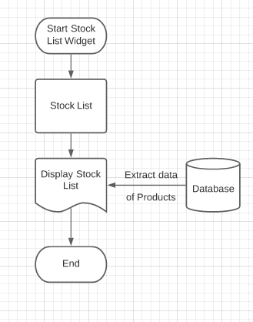

Figure 4.1

* Likewise, Sales List widget shows the sales of the product as well as company’s administrator can add the content of the product and these whole data got updated in the database table.

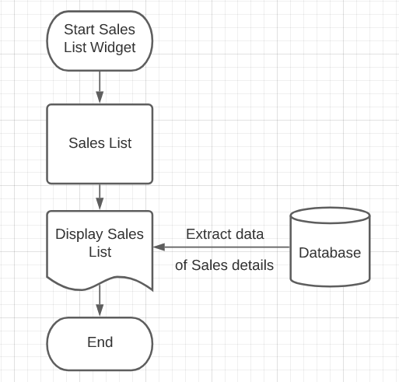

Figure 4.2

* Likewise, Sales Entry widget shows the form in which company can keep an eye over the products which are being sold by their company. So, by filling the form database got updated and new data of sales get stored in the database.

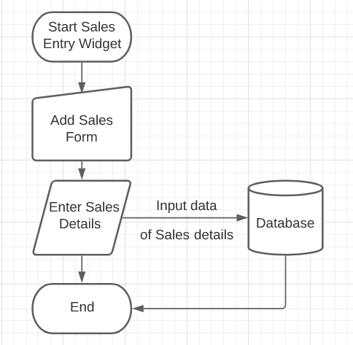

Figure 4.3

* Likewise, Product List widgets shows the purchases of the product as well as company’s administrator can add the content of the product and these whole data got updated in the database table.

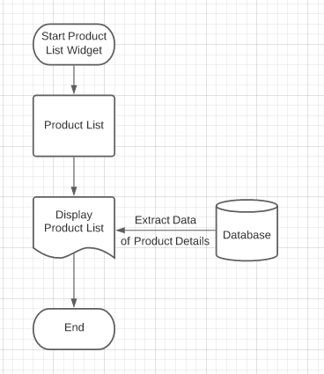

Figure 4.4

* Likewise, Product Entry widget shows the form in which new vendors or any company can be able to purchase the products. So, by filling the form database got updated and new data of purchases get stored in the database.

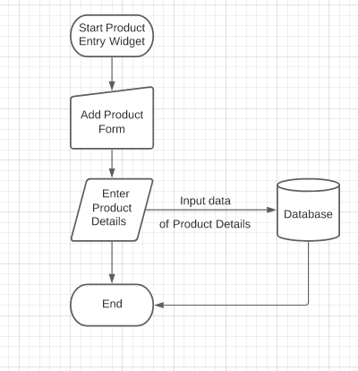

Figure 4.5

* Likewise, Profit – Loss widget is made up to show that the company is running in losses or profits. Also, this data can’t be manipulated and get to know whether the company is making profits or losses. Here, data will be shown in the form of Card widget.

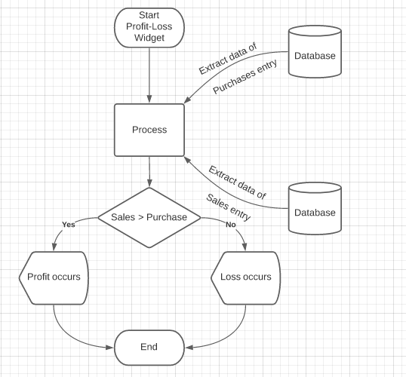

Figure 4.6

Thus, the whole project works like an app. While filling the form of any widgets like for adding new product, if you keep the text box empty then error message will be displayed. So, any important fields don’t get emptied.

**CHAPTER 5: IMPLEMENTATION AND TESTING**

**5.1 Implementation of Project**

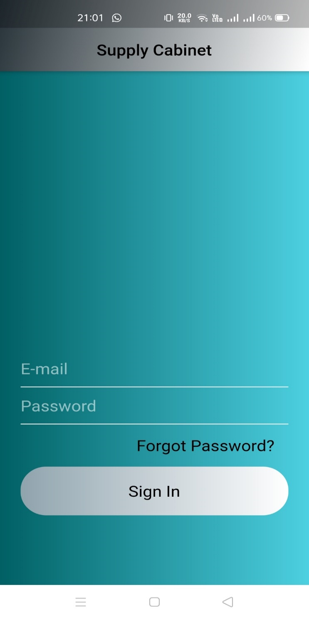

Figure 5.1

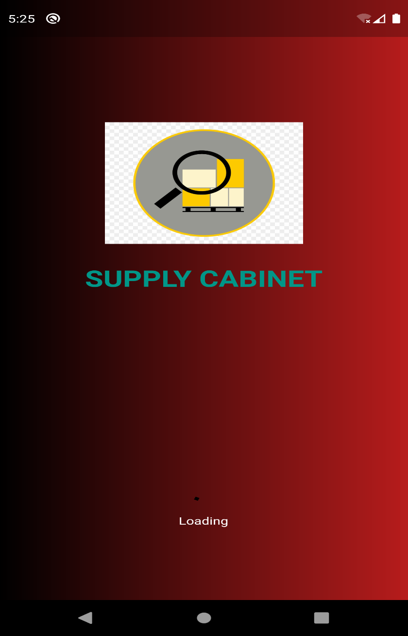

Figure 5.2

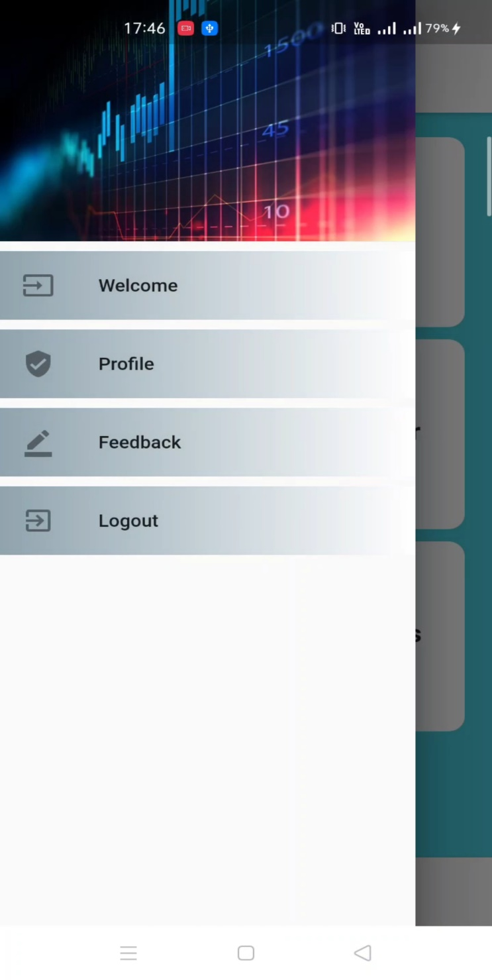

Figure 5.3

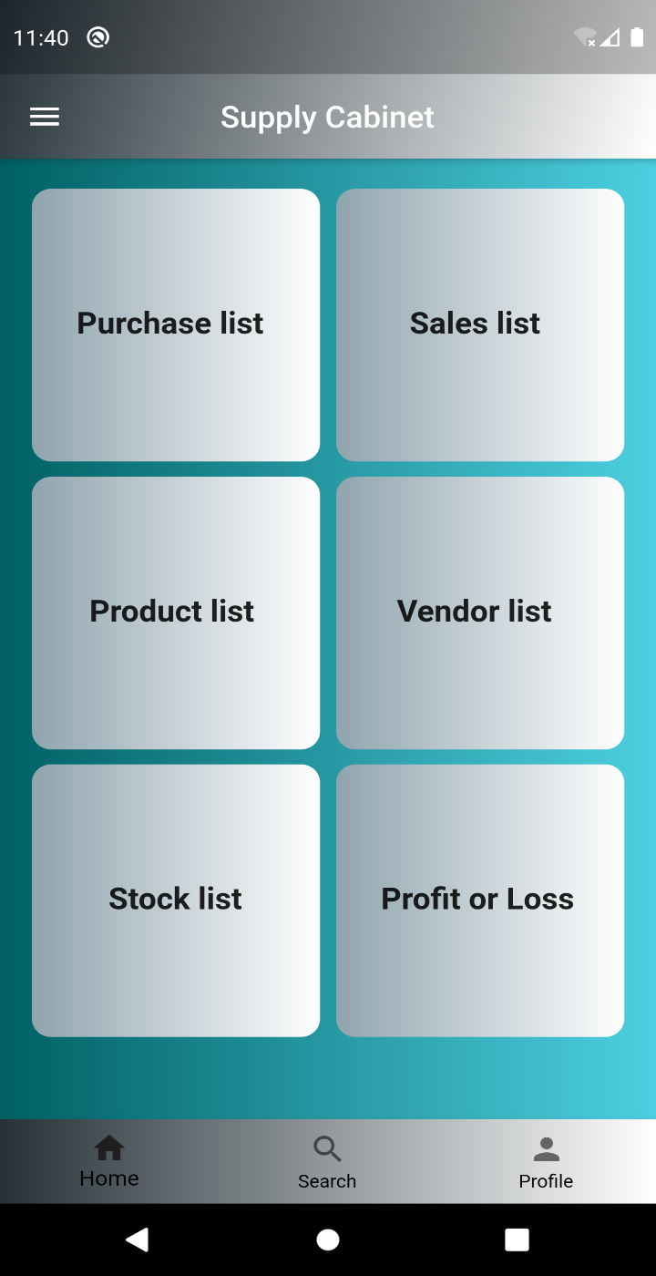

Figure 5.4

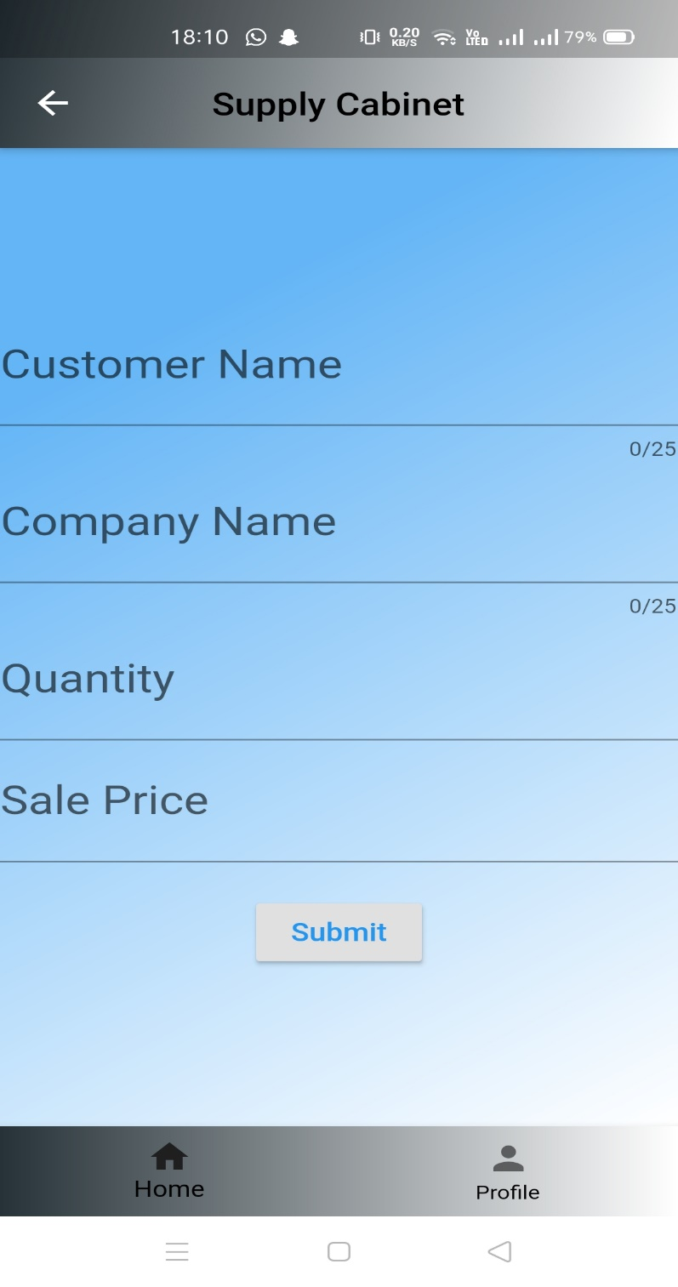

Figure 5.5

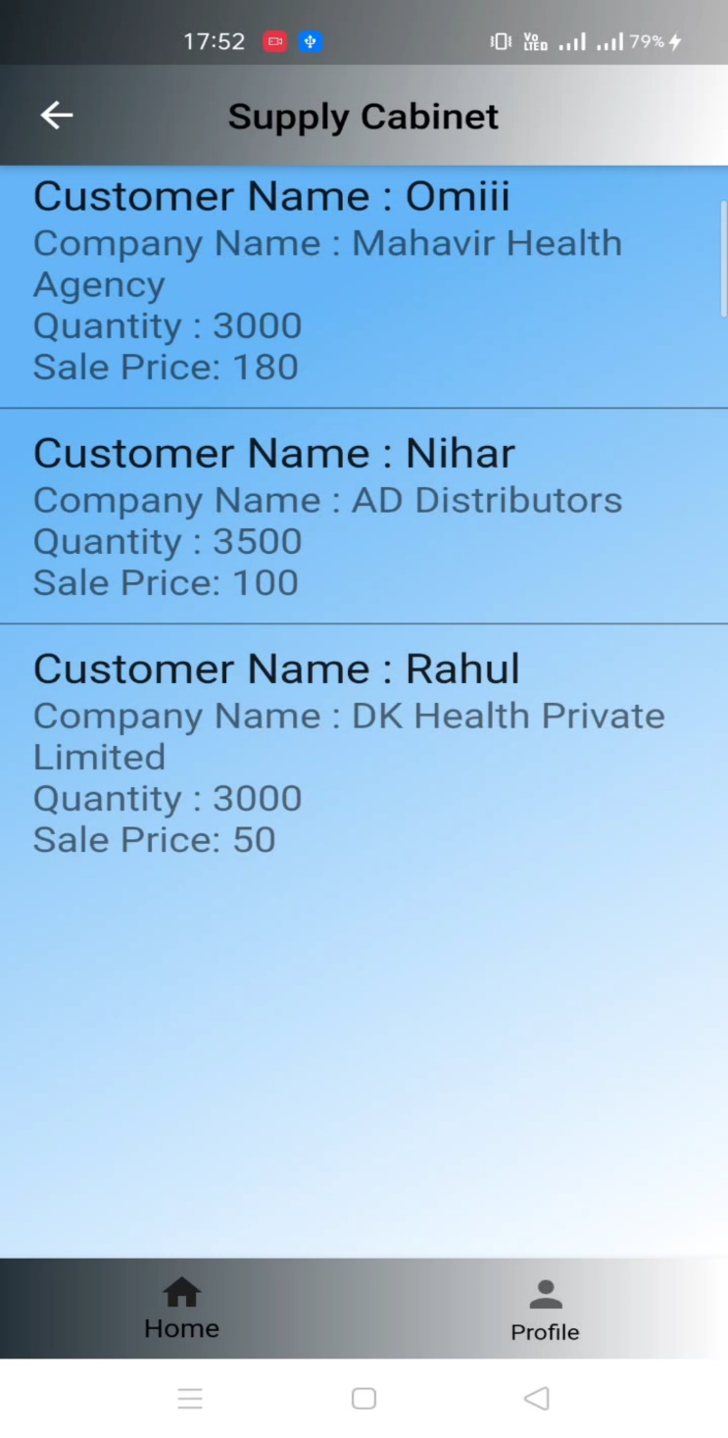

Figure 5.6

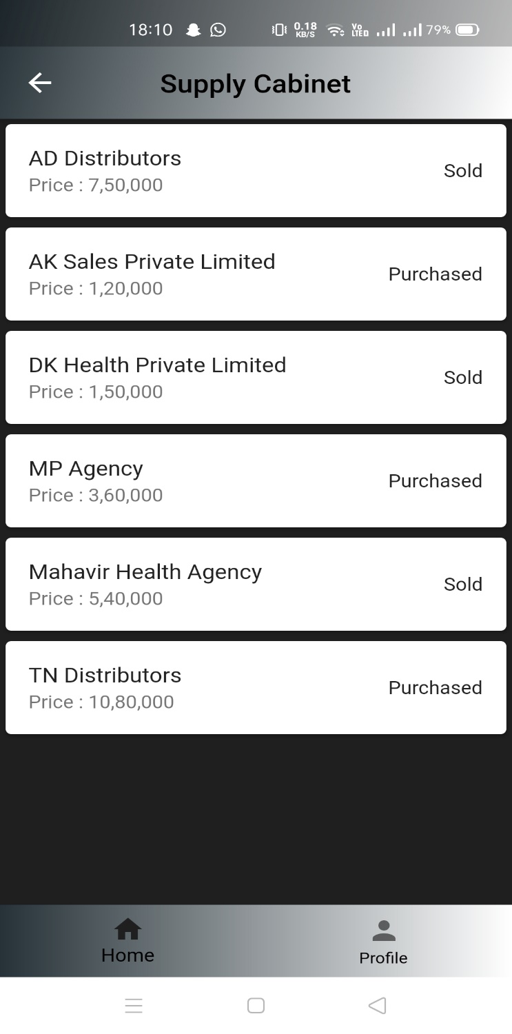

Figure 5.7

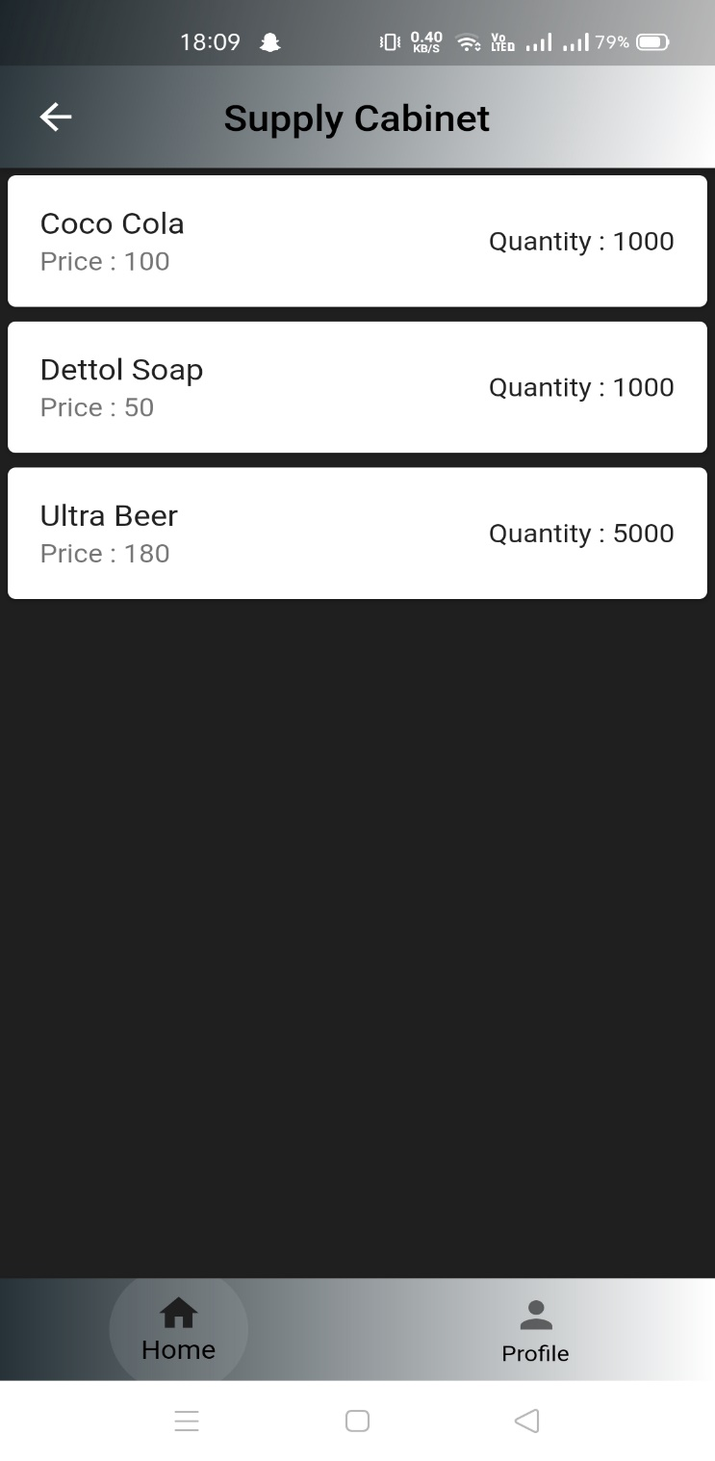

Figure 5.8

**5.2 Testing of Project**

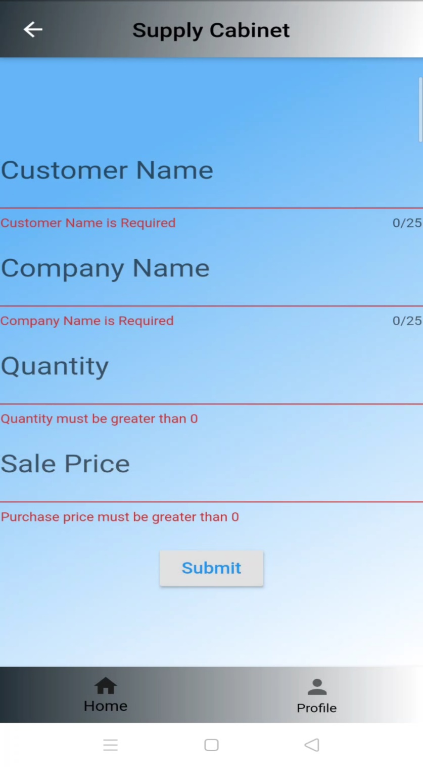

Figure 5.9

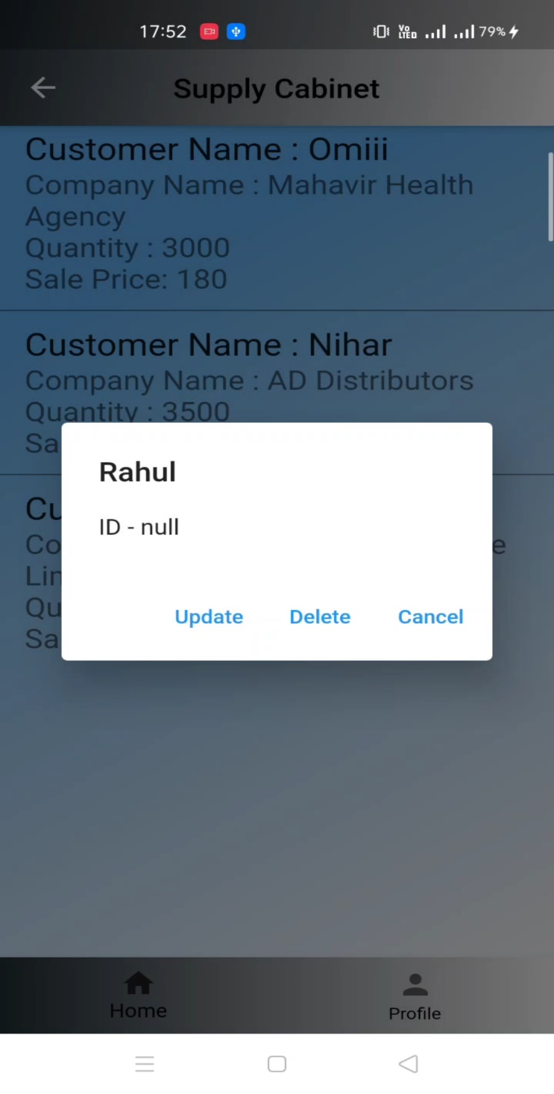

Figure 5.10

**CHAPTER 6: FUTURE PERFORMANCE**

**ENCHANCEMENT**

**6.1 Predictions of the App in Future**

* Collaboration with supply chain partners, coupled with a holistic approach to supply chain management, will be key to effective inventory management.
* The nature of globalization will change, impacting inventory deployment decisions dramatically.
* Increased focus on supply chain security, and concerns about the quality of inventory itself, will be primary motivators to changing supply chain and inventory strategy.
* In order to get a computer-based inventory and sale system to the customer as soon as possible, the entire system will not be delivered at once. A basic system to control sales and inventory will be delivered first. This section contains information on upcoming software to enhance the capabilities of the basic product.
* To ensure that the customer is able to receive a functional database by the set deadline, rather than simply a security system, the full flexibility of the security system will be left for future enhancements.

**CHAPTER 7: CONCLUSION**

**7.1 Self – Analysis**

According to us, this project is completed with the primary functionalities as specified earlier, but then again there is a lot more than this which can be done. So, then it is a challenge to further develop it in to full-fledged software as it was challenge to develop up to this very stage. As we know that app can also be build using only Android Studio but we use Flutter Framework and using this we learned new language with the challenges. As Flutter is a new technology it will be emerging out among the developers. Due to lack of skilled knowledge, project cannot be fully completed so far. This technology will provide us an amazing environment for Android Development and will help a lot.

**7.2 Problems and their Solutions**

* **Lack of full knowledge about the technology**

No clear ideas of how the environment is created from scratch, textured properly into unity. These can be achieved only by more study about Flutter UI technology.

* **For setting up the whole environment**

A lot of time gets waste for setting up the Flutter framework and Android Studio in the laptop.

* **Lack of knowledge about the Database**

No clear ideas of how to create Database or how to run it. So, we have to learn from scratch only. While these takes a lot of time and cannot manage the time over the project. These can be achieved if any one of us would know something about the Database.

**7.3 Summary**

Flutter is emerging as new medium with the potential of having as strong impact. We have the opportunity to build the foundations of interface, experience and interaction design specific for this medium without taking already existing solutions for granted.

I have completed my project work using software engineering and system analysis and design approach. This project is completed with the primary functionalities. Due to lack of skilled knowledge and time constraints, the project cannot be fully completed so far. I have created an experience which performs the basic functionalities but yet there is a scope of improvement and advancement which can be taken care of in the near future.